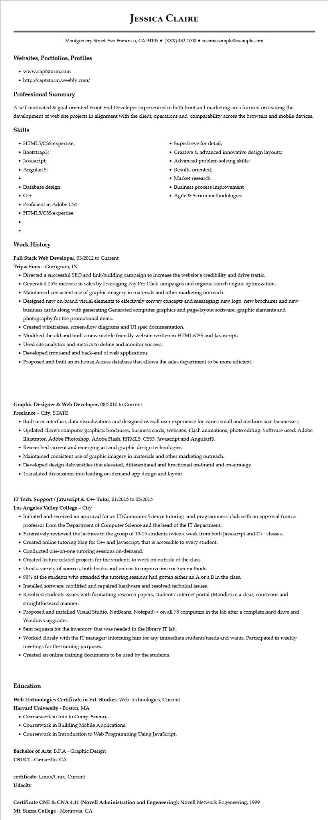
JESSICA CLAIRE
Montgomery Street, San Francisco, CA 94105 ⚫ (XXX) 432-1000⚫ resumesample@example.com
Websites, Portfolios, Profiles
• www.captstorm.com
• http://captstorm.weebly.com/
Professional Summary
A self-motivated & goal-oriented Front-End Developer experienced in both front and marketing area focused on leading the development of web site projects in alignment with the client, operations and comparability across the browsers and mobile devices.
Skills
• HTML5/CSS expertise;
• Bootstrap3;
• Javascript;
• AngularJS;
• Database design
• C++
• Proficient in Adobe CS5
• HTML5/CSS expertise
Superb eye for detail;
• Creative & advanced innovative design layouts;
• Advanced problem solving skills;
• Results-oriented;
• Market research
• Business process improvement
• Agile & Scrum methodologies
Work History
Full Stack Web Developer, 03/2012 to Current
Tripactions - Gurugram, IN
• Directed a successful SEO and link-building campaign to increase the website's credibility and drive traffic.
• Generated 25% increase in sales by leveraging Pay Per Click campaigns and organic search engine optimization.
• Maintained consistent use of graphic imagery in materials and other marketing outreach.
• Designed new on-brand visual elements to effectively convey concepts and messaging: new logo, new brochures and new business cards along with generating Generated computer graphics and page-layout software, graphic elements and photography for the promotional items.
• Created wireframes, screen-flow diagrams and UI spec documentation.
• Modified the old and built a new mobile friendly website written in HTML/CSS and Javascript.
• Used site analytics and metrics to define and monitor success.
• Developed front-end and back-end of web applications
• Proposed and built an in-house Access database that allows the sales department to be more efficient.
Graphic Designer & Web Developer, 08/2010 to Current
Freelance - City, STATE
• Built user interface, data visualizations and designed overall user experience for varies small and medium size businesses;
• Updated client's computer graphics: brochures, business cards, websites, Flash animations, photo editing. Software used: Adobe Illustrator, Adobe Photoshop, Adobe Flash, HTML5, CSS3, Javascript and AngularJS.
• Researched current and emerging art and graphic design technologies.
• Maintained consistent use of graphic imagery in materials and other marketing outreach.
• Developed design deliverables that elevated, differentiated and functioned on-brand and on-strategy.
• Translated discussions into leading on-demand app design and layout.
IT Tech. Support / Javascript & C++ Tutor, 01/2015 to 05/2015
Los Angeles Valley College - City
• Initiated and received an approval for an IT/Computer Science tutoring and programmers' club with an approval from a professor from the Department of Computer Science and the head of the IT department.
• Extensively reviewed the lectures in the group of 10-15 students twice a week from both Javascript and C++ classes.
• Created online tutoring blog for C++ and Javascript, that is accessible to every student.
• Conducted one-on-one tutoring sessions on-demand.
• Created lecture related projects for the students to work on outside of the class.
• Used a variety of sources, both books and videos to improve instruction methods.
• 90% of the students who attended the tutoring sessions had gotten either an A or a B in the class.
• Installed software, modified and repaired hardware and resolved technical issues.
• Resolved students'issues with formatting research papers, students' internet portal (Moodle) in a clear, courteous and straightforward manner.
• Proposed and installed Visual Studio, NetBeans, Notepad++ on all 78 computers in the lab after a complete hard drive and Windows upgrades.
• Sent requests for the inventory that was needed in the library IT lab.
• Worked closely with the IT manager: informing him for any immediate students'needs and wants. Participated in weekly meetings for the training purposes.
• Created an online training documents to be used by the students.
Education
Web Technologies Certificate in Ext. Studies: Web Technologies, Current
Harvard University - Boston, MA
• Coursework in Into to Comp. Science,
• Coursework in Building Mobile Applications.
• Coursework in Introduction to Web Programming Using JavaScript.
Bachelor of Arts: B.F.A - Graphic Design
CSUCI - Camarillo, CA
certificate: Linux/Unix, Current
Udacity
Certificate CNE & CNA 4.11 (Novell Administration and Engeneering): Novell Network Engeneering, 1999 Mt. Sierra College - Monrovia, CA

